Response to the Letter from Nicole Myers
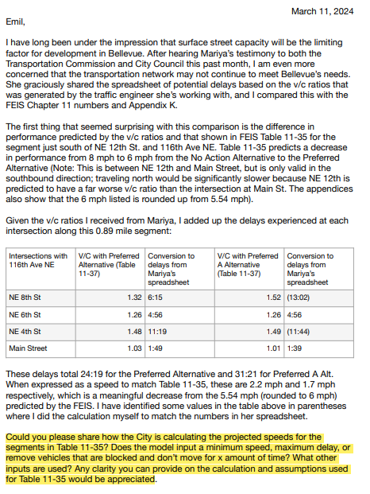
Response:
To estimate future corridor speeds, we first calculated the ratio between the future year and base year travel speeds as projected by our travel demand forecast model (aka BKR model), and then applied this ratio to the base year observed speed for each corridor. The equation used in the calculation is:
The future estimated speed = (future year modeled speed)/(base year modeled speed) x base year observed speed
Where:
- The base year observed speed is mainly from Iteris Inc., a data vender that provides a range of traffic data and services, including roadway speed data. Iteris obtains its data from various sources such as GPS, prob vehicles, connected vehicles, and mobile applications. Like all other data vendors, no single company provides "perfect" data. When Iteris speed data for a particular corridor appeared questionable, we reconciled it with locally observed data from other sources if available.
- The modeled speed is calculated using the BKR model's projected speeds by direction between two intersections. In projecting speed, the model considers the type of roadway, projected vehicle demand, and the number of lanes available to accommodate the demand. It should be noted that the BKR model, like any other macro travel demand forecasting models, is not designed to forecast intersection delays. The speed projection does not explicitly include delays at individual intersections along the corridor. Rather, intersection hindrance to traffic movement is generically reflected in roadway types, mainly limited access (such as freeways) and other roadways controlled by traffic signals and stop signs.
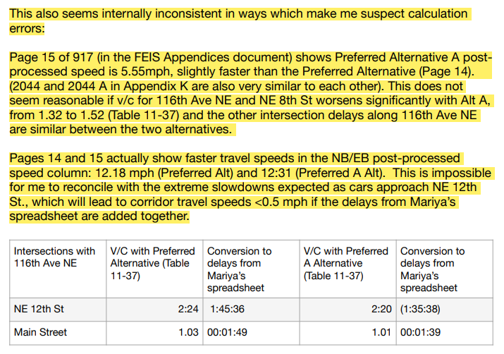
Response:
Intersection V/C ratios and corridor speeds are two different metrics used for evaluating potential vehicle performance from different analytical perspectives. The intersection V/C evaluates turning movement volumes and lane configurations from all four approaches; vehicles entering the intersection from different approaches do not necessarily encounter the same amount of delay.
Using the 116th Corridor between NE 12th St and Main St. as an example, the speed as forecasted by the BKR model doesn’t explicitly include delays at the intersections of NE 12th St., Main St., and those between the two. Regardless of model limitations in forecasting intersection delays, the corridor speed is a meaningful metric for comparing alternatives and identifying potential impacts.
I would also like to point out that the intersection V/C ratio is a metric intended to be used to compare travel demand versus available capacity at these intersections for identifying impacts. It is not intended for estimating delays 20 years in the future at these intersections. This limitation is primarily due to the following considerations:
- The volume in V/C is defined as the demand wanting to enter intersections within a given time period as forecasted by the City’s travel demand forecasting model, not what would actually cross the intersection. It is highly elastic and subject to many factors and constraints that are extremely difficult to quantify many years in advance.
- When demand approaches and exceeds capacity, the delay could increase exponentially. That is, a small change in V/C ratio could result in a big change in delay, making any attempt to estimate intersection delay 20 years out very challenging, and the results would be highly inaccurate.
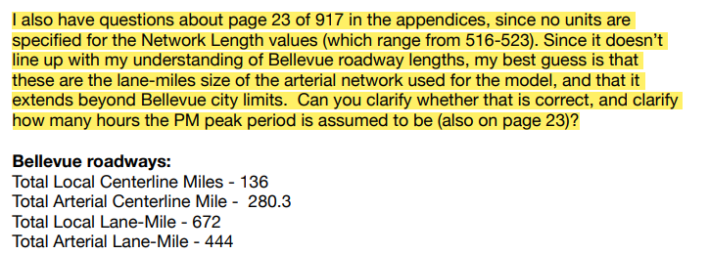
Response:
The network length in the VMT table represents the total length of the roadways by direction in each alternative, with the unit being miles. For two-way roadways, it is two times the centerline miles. The results were derived by adding the lengths of all the roadway segments (by direction) included in the model within the city, including freeways and most city streets. It should be noted that some minor roadways are not included in the model. 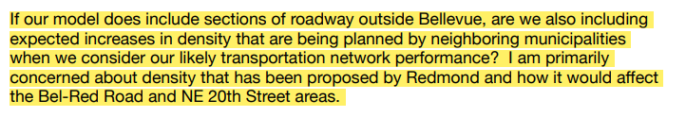
Response:
Yes, the model considers growth outside of the city. The performance analysis results do include the likely transportation impacts due to increased land use intensities in Redmond.

